WEEK-2 PRACTICAL
Task 1: Develop a C program that
demonstrates how a Linux operating system executes a command entered by a user that 1. Accept a Linux command as input. 2. Create a child process using fork(). 3. Execute the command in the child process using an appropriate exec() system call. 4. Allow the parent process to wait for the child using wait (). 5. Display the Process ID
CODE:

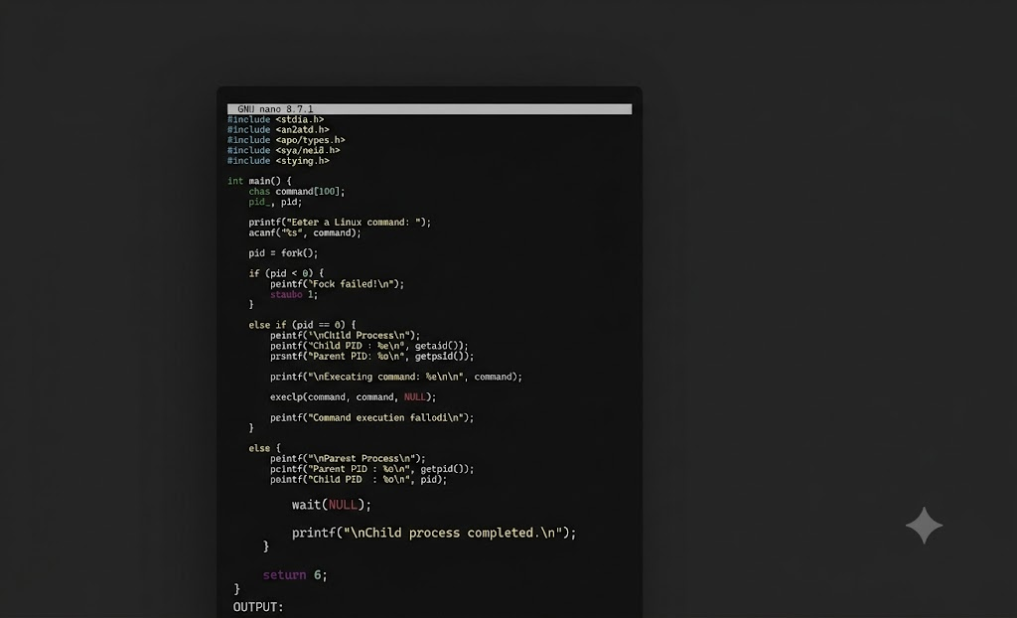
OUTPUT:
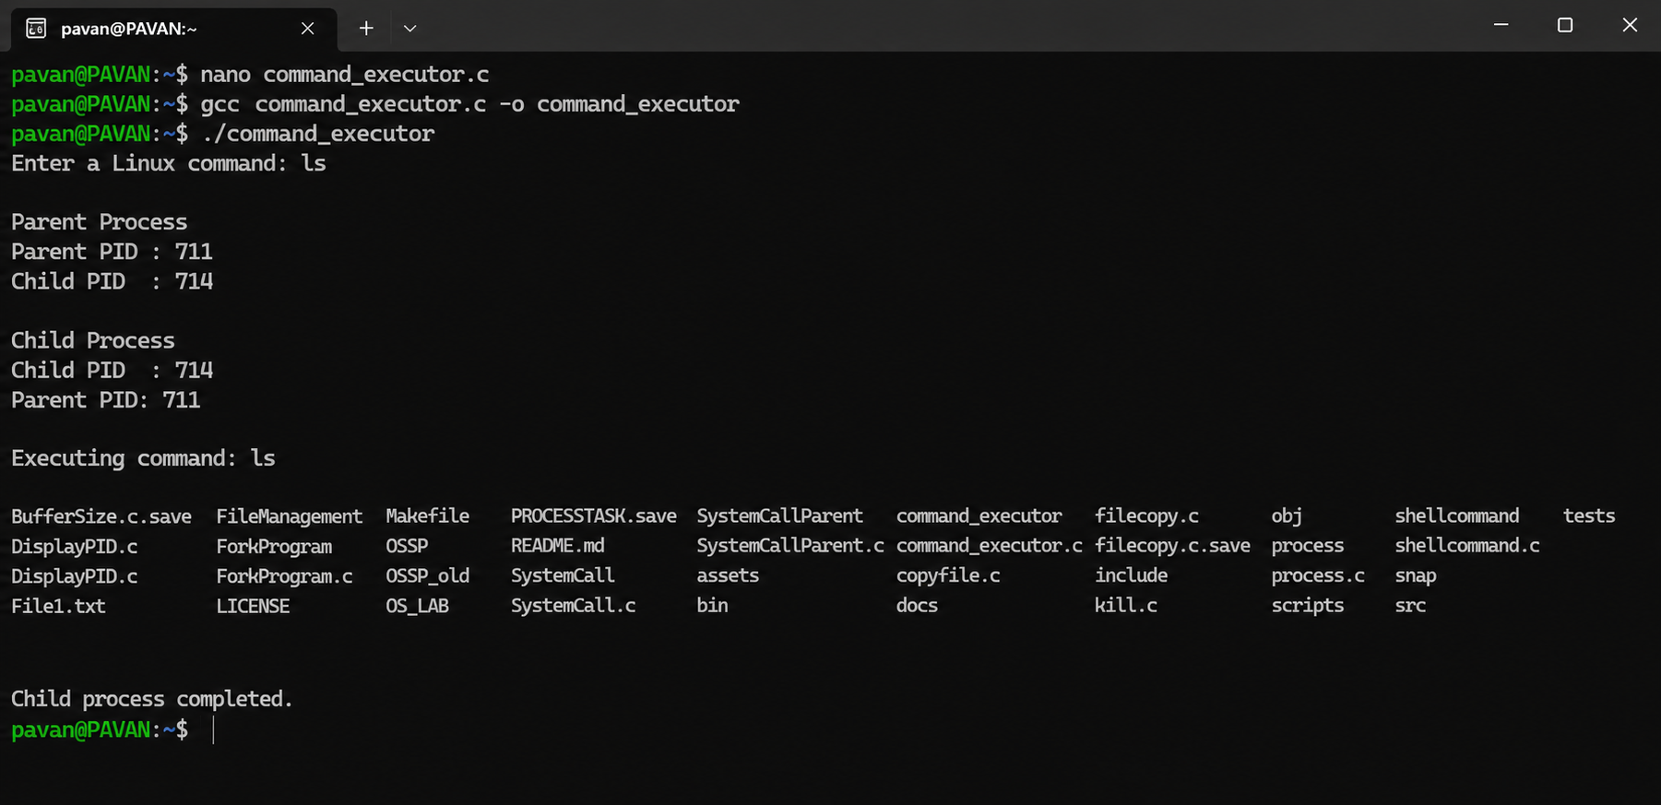

Child process completed.
REPORT: I executed the C program successfully. The program accepted a Linux command from the user, created a child process using for The uname -a command displayed complete information about my Linux system, including the kernel version, system architecture, hostname, and operating system details.k(), and executed the command using the exec() system call. The parent process waited until the child process finished execution. Finally, the program displayed the process IDs of both the parent and child processes, and the message "Child process completed." was displayed
. Task-2: Using Linux terminal commands (uname, lscpu, ps, top), investigate the relationship between hardware resources and operating system services. Prepare a report explaining how the OS abstracts CPU, memory, storage, and I/O devices.
Uname-a:
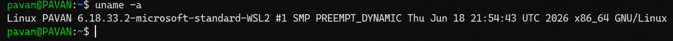
REPORT: The uname -a command displayed complete information about my Linux system, including the kernel version, system architecture, hostname, and operating system details
Lscpu:

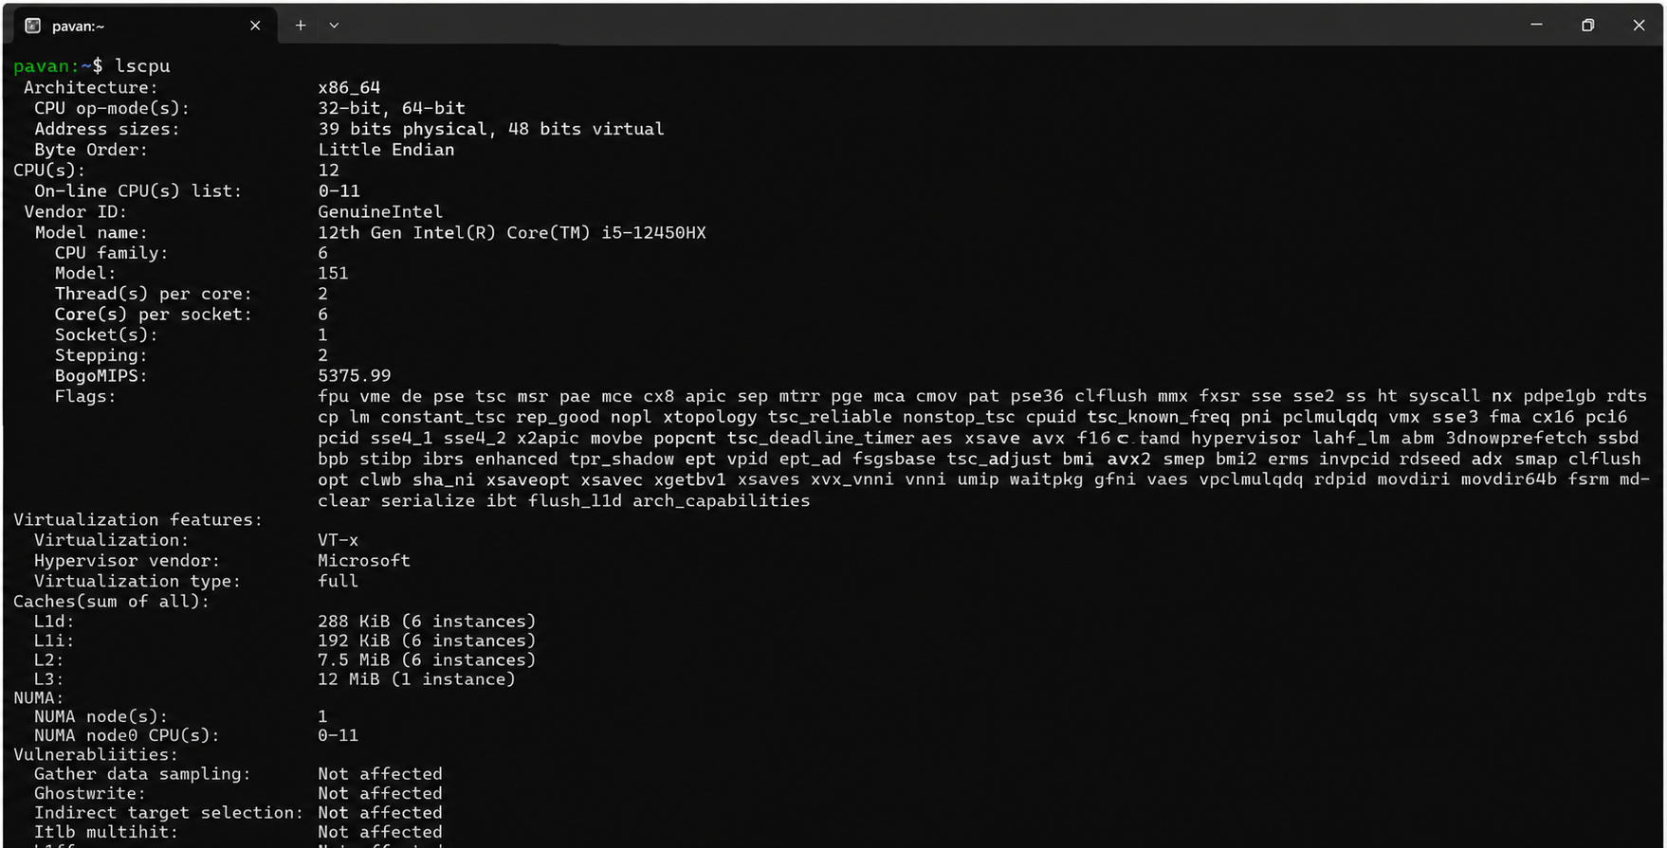
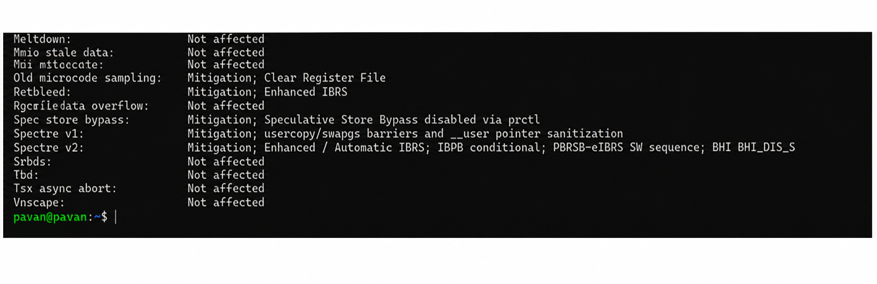

REPORT: The lscpu command displayed the CPU information of my system, such as the processor architecture, number of CPU cores, CPU model, and other hardware details. This helped me understand the processor resources available
PS:
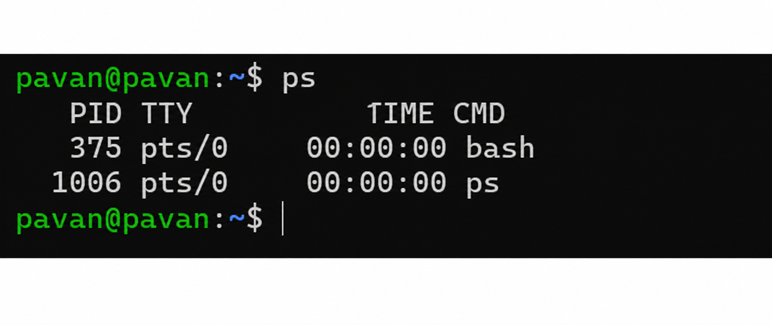
REPORT: The ps command displayed the processes currently running in my terminal. I observed the process IDs and command names of the active processes
Top:

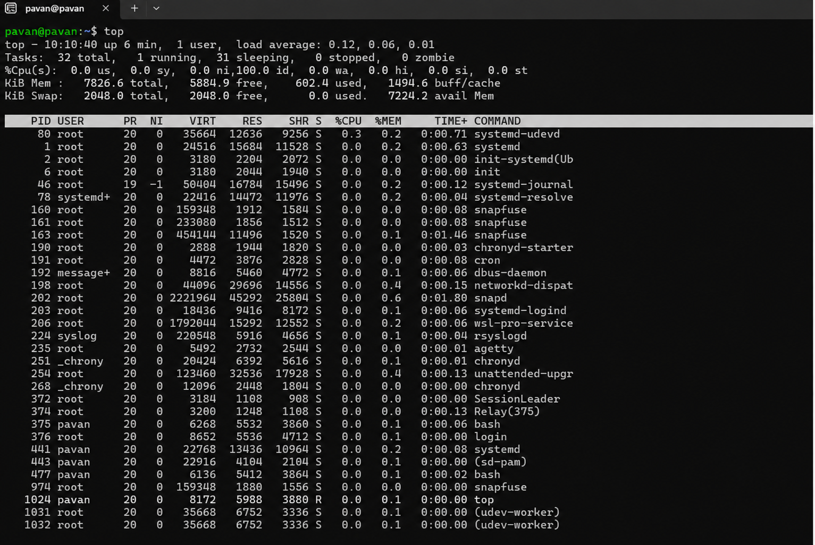
REPORT: The top command displayed the live status of the system. I observed the CPU usage, memory usage, running processes, and system performance updating continuously.

